# Project Design Phase-II

**Data Flow Diagrams**

|  |  |
| --- | --- |
| Date | 25 October 2022 |
| Team ID | PNT2022TMID34120 |
| Project Name | Project - AI - based localization and  classification of skin disease with erythema |
| Maximum Marks | 4 Marks |

# Data Flow Diagrams:

A Data Flow Diagram (DFD) is a traditional visual representation of the information flows within a system. A neat and clear DFD can depict the right amount of the system requirement graphically. It shows how data enters and leaves the system, what changes the information, and where data is stored.

Example: [(Simplified)](https://developer.ibm.com/patterns/visualize-unstructured-text/)

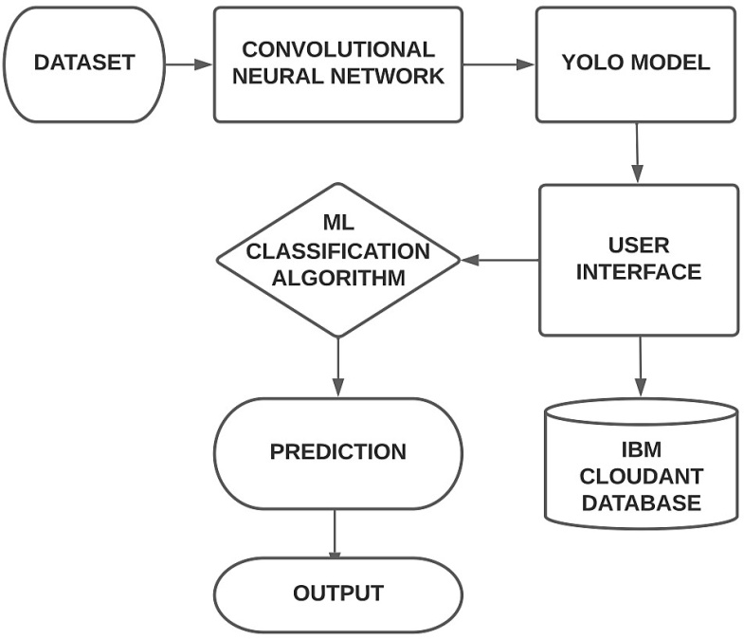

# Data Flow Diagram:

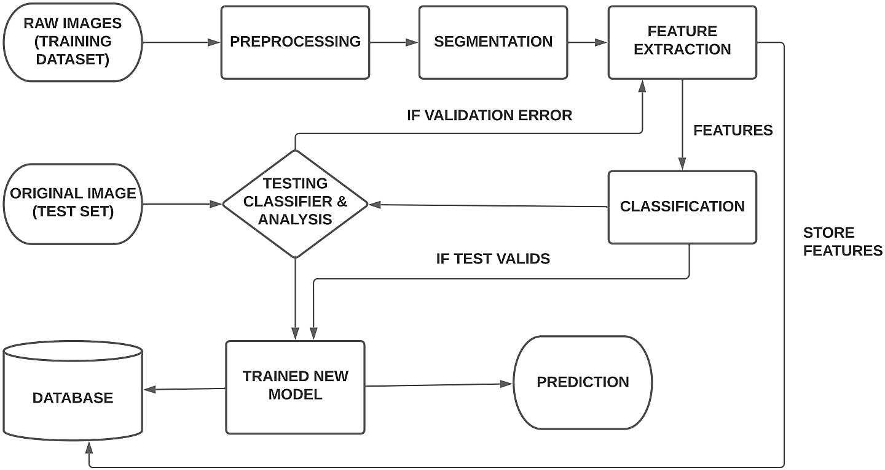

**User Stories:**

|  |  |  |  |  |  |  |
| --- | --- | --- | --- | --- | --- | --- |
| **User Type** | **Functional Requirement**  **(Epic)** | **User Story**  **Number** | **User Story / Task** | **Acceptance criteria** | **Priority** | **Release** |
| **Customer (Mobile user, Web user)** | Registration | USN-1 | As a user, I can register for the application by entering my mobile number, password, and confirming my  password. | I can access my account / dashboard | High | Sprint-1 |
|  |  | USN-2 | As a user, I will receive confirmation SMS once I have registered for the  application | I can receive confirmation SMS & click confirm | High | Sprint-1 |
|  |  | USN-3 | As a user, I can register for the application through email. | I can register & access the dashboard | Medium | Sprint-2 |
|  |  | USN-4 | As a user, I will receive the confirmation mail | I can receive the confirmation mail and click  confirm | Medium | Sprint-2 |
|  | Login | USN-5 | As a user, I can log into the application by entering login credentials  legitimately | I can access the dashboard by logging into the application | High | Sprint-2 |
|  | Dashboard | USN-6 | As a user, I can upload my images and get my details of skin  disease | I can upload my image and get the details | High | Sprint-3 |
|  | Logout | USN-7 | As a user, I can logout successfully | I can logout with the confirmation of the popup message | Medium | Sprint-1 |

|  |  |  |  |  |  |  |
| --- | --- | --- | --- | --- | --- | --- |
| **Customer Care Executive** | Feedback | USN-1 | As a customer care executive, I can able to interact with all the customers and get their feedback which is used to enhance the  scope of project | I can get the feedback from customers which will help in improving the scope of project | Medium | Sprint-4 |
| **Administrator** | Image processing, localization, Classification and Prediction | USN-1 | The uploaded image is preprocessed and fed into the trained yolo model to predict the disease type and the areas affected | The uploaded image is preprocessed and fed into the trained yolo model to predict the disease type and the areas  affected | High | Sprint-4 |
|  | Report generation | USN-2 | Based on the prediction of the skin disease the health care report is generated to provide  feedbacks | The prediction of the skin disease the health care report is generated to provide  feedbacks | Medium | Sprint-4 |